Date: | 23rd July 2020
Assessors Name: |  | Ben Doyle |  | Reference Number: |  | 1 |  |  | Review Date: |  |  | Ongoing – as per government guidance updates
Description of assessment |  |  | Coronavirus (COVID-19)
Location Details |  |  | Herts & Essex Sports Centre / Passmores / Bullfields Park / Burnett Park / Vantorts Park

Identified Hazards | Who may be affected | Risk Level before control measures  S x L = R |  |  |  | Existing control measures | Additional Control measures required | To be actioned by | Completion date | Final Risk level  S x L = R
 |  | S | L | R | RR |  |  |  |  | S | L | R | RR
Catching / Spreading | Employees, client, public | 5 | 3 | 15 | H | - Facilities will contain suitable levels of soap and antibacterial gel.  - Coaches will be asked to wash hands with soap regularly and thoroughly, for at least 20 seconds.  - PPE equipment including masks, sanitiser and gloves will be made available to all staff.  - Contact with personnel suspected of having caught COVID-19 will be avoided.  - Employees are reminded to not touch their eyes, nose or mouth if their hands are not clean  - We will also work towards any cleaning / infection control requirements outlined by lettings.  - Employees will be told to self-isolate for 7 days should they find they have a new, persistent cough and/or a high temperature or show any other Covid-19 symptoms  - Should employees disclose that personnel living with them are self-isolating, they should be encouraged to do the same for 14 days as per Government guidance.  - Protective screening has been fitted to the reception area to reduce the risk of transmission  - Additional hand sanitiser units have been installed to allow for increased hand cleaning.  - Queuing signage (cones) has been added to the floor to ensure members of the public maintain a 2m+ distance while waiting to be served.  - Only one member of staff will work behind the reception area at one given time to prevent working within close proximity  - Children participating in Holiday Camps will be placed in daily bubbles to limit the number of interactions across a day. They will also have an allocated area for breaks and lunch with staggered times. The bubbles will contain no more then 15 children to 1 adult. | - In the case of a positive result for COVID-19 for a staff member we will immediately request a test, the staff member will self-isolate until the results are known and if positive will continue to isolate for 7 days. We will also support the NHS Test & Trace service.  - In the case of a positive result for a child during our Holiday Camps we will immediately close the bubble in which the child has attended. We will then support the NHS Test & Trace service. Any staff members working within this bubble will be advised to be tested. They will also be advised to self-isolate for 14 days. Should the result of their test be negative they will be allowed to return to work with immediate effect. | B.D |  | 5 | 1 | 5 | M

Identified Hazards | Who may be affected | Risk Level before control measures  S x L = R |  |  |  | Existing control measures | Additional Control measures required | To be actioned by | Completion date | Final Risk level  S x L = R
 |  | S | L | R | RR |  |  |  |  | S | L | R | RR
Employee travel plans | Employees, client, public | 5 | 3 | 15 | H | - We will ask employees to inform us if they are leaving the country.  - We will provide relevant government guidance in line with the area / country that they are visiting.  - Self-isolation will be enforced in line with the area / country guidance. |  | B.D |  | 5 | 1 | 5 | M
Lack of awareness | Employees, client | 5 | 3 | 15 | H | - The latest government campaign posters will be displayed in the welfare areas and in suitable places around site.  - We will continually adopt and review new government, Public Health England and WHO guidance as and when it is available.  - Specific posters have been placed around the Sports Centre with all relevant information. |  | B.D |  | 5 | 1 | 5 | M
Handling of Food & Beverages | Employees, Public | 2 | 2 | 4 | M | - Staff will wear gloves when making hot beverages.  - Additional cleaning of the machine, fridge and surfaces will have increased cleaning.  - All food for lunches will be provided by schools professional Catering Team. |  | B.D |  | 2 | 1 | 2 | L
Use of equipment | Employees, public | 2 | 2 | 4 | M | - We will minimise the amount of equipment used on our Holiday Programme.  - When putting equipment out for lettings staff will be required to wear gloves. |  | B.D |  | 2 | 1 | 2 | L
Larger gatherings than recommended | Employees, Public, Lettings | 5 | 3 | 15 | H | - We will work with all lettings on arrival and departure protocols to limit large group gatherings in communal areas.  - Amount of seating and tables has been reduced in reception to limit the amount of people who could gather within the area. |  | B.D |  | 5 | 1 | 5 | M
Adverse weather | Employees, Public | 3 | 3 | 9 | M | - If activities that are taking place have to move inside due to extreme weather we will make sure that there is adequate space inside until children can be collected |  | B.D |  | 3 | 1 | 3 | L
Public not following NGB guidance for individual sports | Employees, Public | 3 | 3 | 9 | M | - We will publicise up to date National Governing Body guidelines to raise awareness. |  | B.D |  | 3 | 1 | 3 | L
Risk of transmission whilst providing First Aid | Employees, Public | 3 | 2 | 6 | M | - Designated first aiders will be on duty at any given time.  - PPE will be made available to staff wear during any first aid undertaken. |  | B.D |  | 3 | 1 | 3 | L

Guidance Notes
SEVERITY | 5 | 5 | 10 | 15 | 20 | 25
 | 4 | 4 | 8 | 12 | 16 | 20
 | 3 | 3 | 6 | 9 | 12 | 15
 | 2 | 2 | 4 | 6 | 8 | 10
 | 1 | 1 | 2 | 3 | 4 | 5
 |  | 1 | 2 | 3 | 4 | 5
 | LIKELIHOOD

LIKELIHOOD
5 | Almost Certain – Very High Risk
4 | Probable – High Risk
3 | 50/50 – Medium Risk
2 | Improbable – Low Risk
1 | Almost impossible – Low Risk

SEVERITY
5 | Fatality – Very High Risk
4 | Severe incapacity – High Risk
3 | Absent 3 weeks – Medium Risk
2 | Absent less than 1 day – Low Risk
1 | Insignificant – Low Risk

1–4 LOW | 5–9 MEDIUM | 10–15 HIGH | 16–25 VERY HIGH
Continue with existing control, however monitor for changes.  Implement any additional control measures required, within the timescales given in the  risk assessment. | Requires attention to reduce the rating as well as regular ongoing monitoring.  Implement any additional control measures required, within the timescales given in the  risk assessment. | Requires immediate attention to bring the risk down to an acceptable level. Implement the control measures required, within the timescales given in the risk assessment and continue to review working practices to reduce the probability of an accident to the lowest possible level. | Stop immediately – the risk is too high.  Take immediate action to reduce the risk to  the lowest level possible.

Additional comments:
- This risk assessment needs to be discussed with employees before they operate the plant/equipment to ensure compliance with all control measures through their understanding
- Employees are to sign an acknowledgement sheet for their understanding of this risk assessment
- The risk assessment is to be reviewed on an annual basis, or sooner if changes are made to the plant or working practices, or after an accident/near miss
- This risk assessment must be approved by the nominated person for health and safety before being issued as a live document

Assessor 1 name: |  | Signature: |  | Date:

Assessor 2 name: |  | Signature: |  | Date:

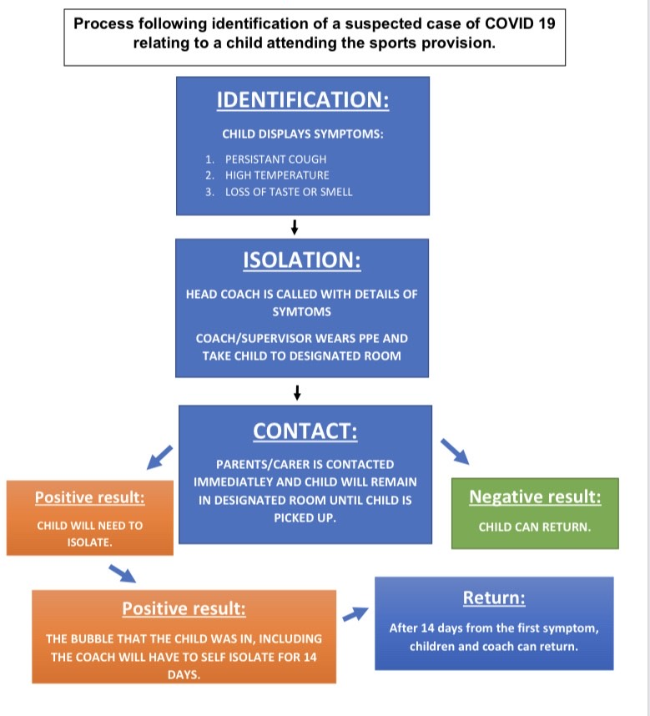
I, the undersigned, have been fully briefed on this risk assessment and other control measures in place to reduce the risk of injury to the lowest possible level.
I fully understand my duties as an employee, to follow the control measures in this risk assessment and the method statement.
Employee name | Job description | Date | Employee comments/recommendations | Signature

